**Team Union Pacific**

**Michigan State University**

Switch Alignment Mobile Game

Project Plan

Spring 2023

**Union Pacific Contacts**

Jeff Girbach

Laura Greet

Jason Taullie

Adam Halley

**Team Union Pacific**

Jiayue Chai

Zack Joyce

Alexa Kelley

Mike Walton

Daniel Wylie

**Table of Contents**

Executive Summary 2

Functional Specifications 3

Design Specifications 3

Overview 3

Screen Mockups 4

Technical Specifications 8

System Architecture 9

Overview 9

System Components 10

Risks Analysis 10

Schedule 11

**Executive Summary**

Union Pacific operates and maintains one of the largest railroad systems in the United States. The freight-hauling railroad transports thousands of goods and materials each day, including food, automobiles, coal, and chemicals. The company was originally founded under the Pacific Railroad Act of 1862, and now operates 8,300 locomotives and over 32,000 miles of railroads nationwide. Headquartered in Omaha, Nebraska, Union Pacific serves as a blueprint for efficient, reliable, and sustainable transportation.

Safety is a top priority for Union Pacific. In the rail industry, misaligned railroad switches can be a major safety threat. For this reason, employees must be well-trained to recognize proper switch alignment. Identifying switch alignment both quickly and accurately is crucial for Union Pacific employees in the event of a misaligned switch. This is achieved by diligent training and frequent practice. Our goal is to create an entertaining mobile game to help train employees in proper switch identification. The game will be a realistic looking simulation with various weather conditions and scenarios. The game will also have leaderboard features to help motivate employees to keep improving their score and, in turn, keep practicing and learning.

**Functional Specifications**

With a company as large as Union Pacific operating in such a vast area, there are many possible switch alignment scenarios that any employee might encounter. Employees are often moved around, so training for only the location an employee begins in is not practical and will slow performance if they are moved to a place covering a vastly different environment because they will need to be trained again. From rain and snow to a plethora of different switches and indicators, it can be difficult to effectively train a new hire, or continue preparing established workers, for all the environments they might need to operate in. Not being properly trained for all conditions can cause mistakes to arise, which is costly since the frequent outcome of a misaligned switch is train derailment.

Getting hands-on experience for all scenarios would involve a long process of moving workers from place to place and going through many hours of training at each new location. This process is taxing on the workers and costly to the company. However, technology has evolved to the point where it is possible to simulate different scenarios and present them to better prepare an employee, without having to move them across the country just for training.

Our Switch Alignment Mobile Game is an effective and innovative solution to these challenges. The game offers the users various scenes and challenges, which help them to learn and practice identifying switch alignment in a variety of environments and conditions to better prepare them for real world scenarios. To provide a realistic experience, the game has features of dynamically changing time and random weather conditions. The users can also play the game in one specific weather condition to further develop their skills. With a competitive leaderboard and captivating gameplay, new and established employees of Union Pacific have the opportunity to be entertained during downtime, while simultaneously furthering their switch alignment identification skills. In addition, an offline mode is available for the users who would like to practice the game and do not want their scores to appear on the leaderboard.

**Design Specifications**

**Overview**

Switch Alignment Mobile Game allows new field employees of Union Pacific to learn and practice aligning switches in different conditions in a new, fun, and interactive way. All users have Union Pacific accounts that are used for logging in to the game. The scores of users are displayed on a leaderboard with corresponding usernames. This leaderboard can be checked from the main menu and will be shown at the end of every run. The game is designed as infinite runner style with randomized and realistic scenarios to ensure a fun and engaging learning environment. The game is in first-person view; the user can swipe left and right to tell which way a railroad switch is aligned; and down if there is a gap switch. After identifying the gap rail, the railroad tracks will be correctly aligned automatically, then the user needs to swipe left or right as other non-gap switches.

**Screen Mockups**

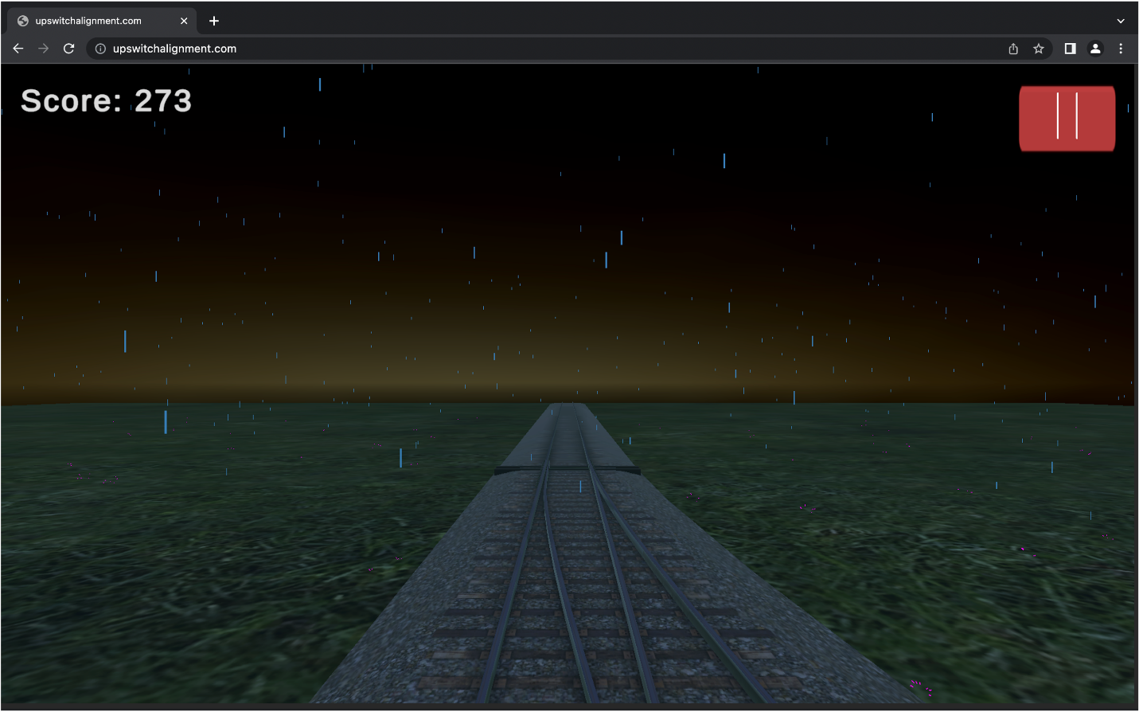

Figure : Web-interface of Switch Alignment Mobile Game

Figure 1 displays the web-interface of Switch Alignment Mobile Game. On the top right corner of the screen shows the user’s score in the current run; on the top right corner of the screen is the pause button.

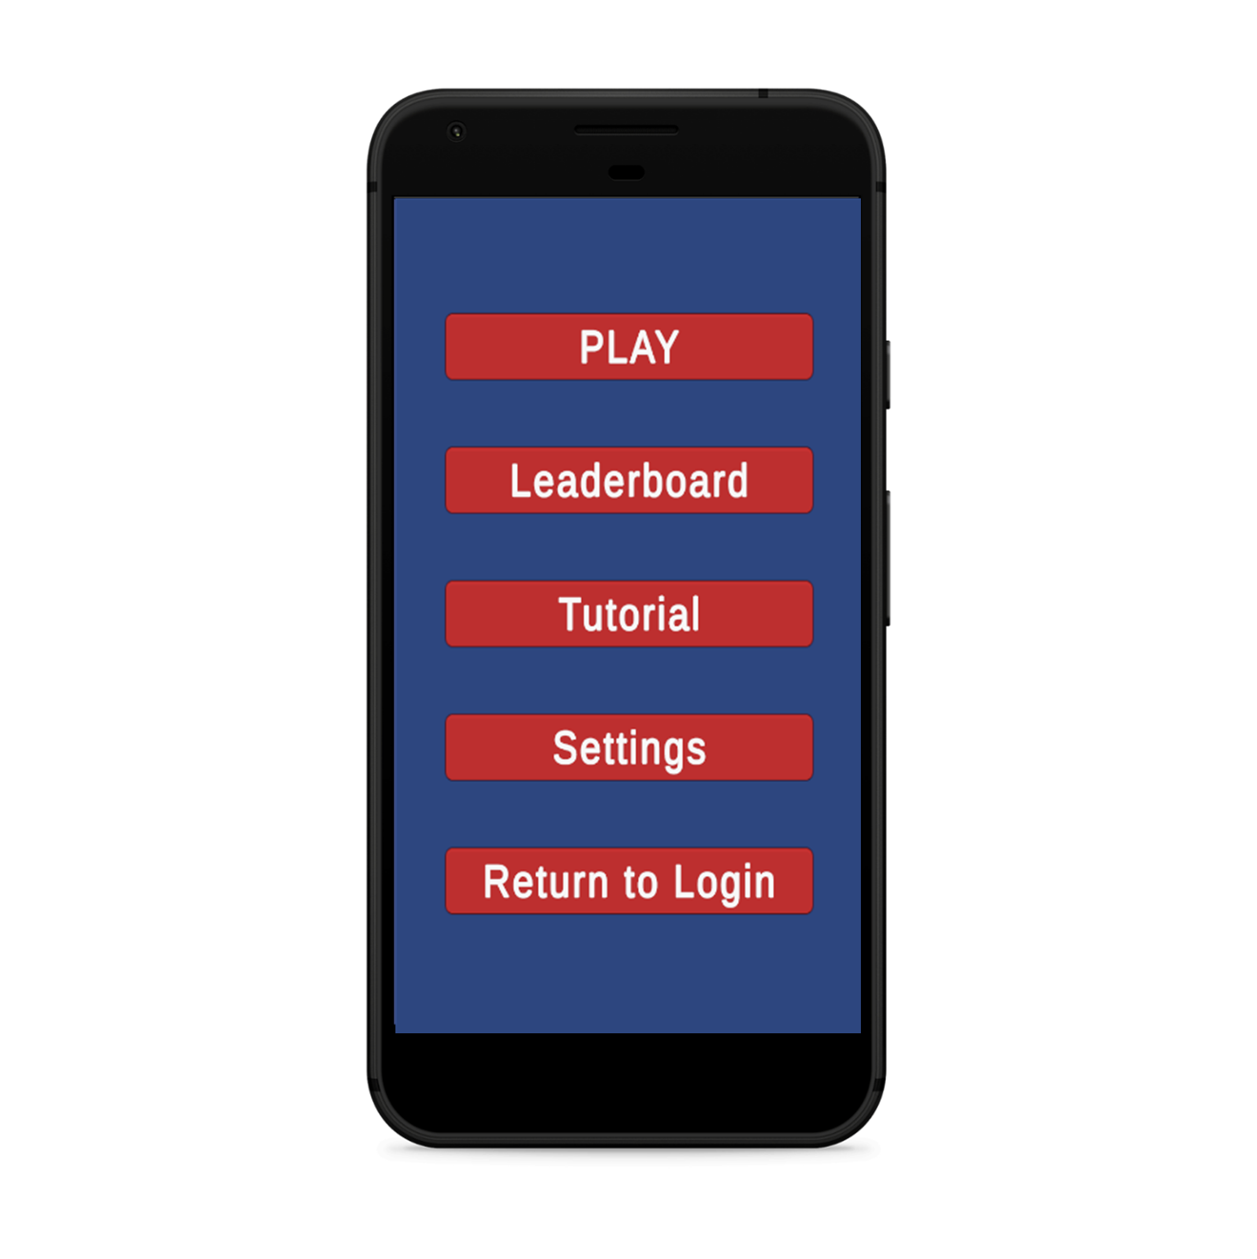

Figure : Main Menu of Switch Alignment Mobile Game

Figure 2 displays the main menu of Switch Alignment Mobile Game. The users can access the game by clicking on the “PLAY” button; or the game tutorial by clicking on the “Tutorial” button. “Leaderboard” takes the users to the leaderboard of the game, where the users can track their scores and compete with each other. In “Settings”, the users are able to set the specific weather types they would like to practice in the game. Finally, “Return to Login” allows the users to go back to the login page.

Figure : Gameplay of Switch Alignment Mobile Game on an Android device

Figure 4: Game Over Menu of Switch Alignment Mobile Game

Figure 4 displays the game over menu of Switch Alignment Mobile Game. The “Leaderboard” button is disabled if the user is playing in offline mode, and their scores will not be updated to the leaderboard. “Try Again” restarts the game; and “Quit To Menu” allows the users to go back to main menu.

Figure : Snowy Weather Gameplay of Switch Alignment Mobile Game

Figure 5 displays the snowy weather in gameplay. In snowy weather conditions, the railroad tracks are covered by snow, which makes it more difficult to see the switches. Snowy weather is included in the game to provide a more realistic environment and increase the level of difficulty.

**Technical Specifications**

**System Architecture**

Figure 6: System Architecture of Switch Alignment Mobile Game

**Overview**

The Switch Alignment Mobile Game will have all front-end and game architecture components created in Unity, and all back-end components handled by Oracle Database services. Unity will communicate with the database through a RESTful API which will be developed using Spring framework.

The front-end components in Unity will be split across five distinct scenes: User Authentication, Main Menu, Settings, Game Instance, and Game End Menu. Users will begin at User Authentication, where they will login to the database using their Union Pacific employee credentials. Once authenticated, users will load into the Main Menu scene, where they can either begin a game, navigate to settings, or display a leaderboard. The leaderboard will have two tabs, one to display the scores of all the employees and one to display scores of the user’s service unit. Both tabs will have data sorted in ascending order. Once a user loads into the Game Instance scene they will be presented with various switch alignment scenarios and will earn points as they correctly identify them. If a switch is misidentified the Game End Menu scene will be loaded, displaying the users high score, along with an option to display a leaderboard, return to Game Instance, or return to Main Menu.

The back-end component of the project will include an independently hosted Oracle Database along with a REST API developed using Spring. The Oracle Database will feature fake data formatted similarly to what is used in Union Pacific’s own database. This data will include each employee's name, identification number, high score, and service unit members by employee ID. The front-end component in Unity will access this data to provide user authentication, leaderboards, and to track each user's high score. This data will be accessed through the REST API. Once the project is completed, Union Pacific’s own backend database team will migrate the project to their own backend services along with including their own user authentication.

**System Components**

**Oracle Database:** The Oracle Database will be used for all back-end purposes of this project. For testing purposes, a free demo database will be hosted by our team with fake employee data. Once completed, the project will be migrated to a new back end hosted on Oracle by Union Pacific’s own database team.

**Spring:** Spring will be used to create a REST API to enable communication between our Oracle Database back-end and Unity front end. This will allow the front end in Unity to call SQL queries to the Oracle Database.

**Unity:** Unity will be used to create the switch alignment simulation. Everything that involves the actual gameplay will be created in Unity. Unity will be used to create the weather conditions, terrain, and railroads.

**Zebra Phone:** The Zebra phone is the primary device used by Union Pacific employees. For that reason, it is imperative that this application is functional on that device.

**Risks Analysis**

**Risk 1​: Assure REST API is compatible with both the client’s preferred database and Unity framework.**

**Difficulty:** Medium

**Description:** A REST API is necessary to communicate between the client’s database and the Unity project.

**Mitigation:** Create a REST API capable of communicating with an SQL database and determine how to utilize it in Unity to call queries.

**Risk 2​: Incorporating snow as an environmental obstacle.**

**Difficulty:** Medium

**Description:** No assets on the App Store include snow models and we were not provided any resources to accommodate for this, we will need to figure out a work around to add these environmental elements.

**Mitigation:** Create our own models to show snow on the tracks or acquire models with proper licensing from a free source.

**Risk 3​: Game performance/Battery usage when running on Zebra phone, which is used by Union Pacific employees​​.**

**Difficulty:** Medium

**Description:** The employees of Union Pacific play the Switch Alignment Mobile Game using a Zebra phone, but team members only have Android and IOS devices. So, there will probably be bugs or errors that are not tested until using a Zebra phone.

**Mitigation:** Team Union Pacific will use Unity device simulator to simulate screen dimensions​​, and possibly test on our own Android devices.

**Risk 4​: Scalability of database and queries based on employees active​​.**

**Difficulty:** Medium

**Description:** There may be a cost to use a database if the database is large. Team Union Pacific is not sure about how large the clients want the database to be.

**Mitigation:** Team Union Pacific will consult clients about scale, make sure the cost of queries isn't beyond their comfort zone​.

**Schedule**

**Week 1: 1/9 - 1/14**

* Joined Teams channel for communication
* First meeting with team and clients

**Week 2: 1/15 - 1/21**

* First triage meeting with Team Manager (Luke Sperling)
* First status report of project
* Second meeting with clients to follow-up unclear details of project
* Team photos
* Start project plan document draft
* Sign Intellectual Property Agreement and Non-Disclosure Agreement documents

**Week 3: 1/22 - 1/28**

* Finish first draft of project plan document and share with clients
* Create mock-up screens for different use cases
* Finish project plan presentation slides

**Week 4: 1/29 - 2/4**

* Project plan presentation
* Review and submit project plan document
* Begin working on generating railroad tracks and creating REST API

**Week 5: 2/5 - 2/11**

* Create main page of the game
* Set up and test database
* Add railroad tracks to the game

**Week 6: 2/12 - 2/18 (No classes, no meetings)**

**Week 7: 2/19 - 2/25**

* Finish Alpha presentation slides
* Add dynamically changing time feature to the game
* Connect Unity to REST API

**Week 8: 2/26 - 3/4**

* Team Alpha presentation
* Team Design Day booklet page
* Set up Tomcat web server
* Add scoring feature to the game
* Basic game loop

**Week 9: 3/5 - 3/11 (Spring break, no meetings)**

**Week 10: 3/12 - 3/18**

* Add random weather system to the game
* Add decision system to the game
* Upload score to leaderboard

**Week 11: 3/19 - 3/25**

* Improve track generation and camera movement
* Add put call to update score
* Share first version of game with clients

**Week 12: 3/26 - 4/1**

* Finish Beta presentation slides
* Second status report, project feature complete
* Add tunnel system to the game
* Add offline mode
* Sorting feature in leaderboard
* Meet with clients and discuss stretch goals

**Week 13: 4/2 - 4/8**

* Fix any bugs found in the game
* Add tutorial to the game
* Add weather controller in game settings

**Week 14: 4/9 - 4/15**

* Team Beta presentation
* Test the game and fix more bugs
* Edit project plan document
* Improve UI
* Start working on project video script

**Week 15: 4/16 - 4/22**

* Finish editing project video
* Meet with client and make final changes to the game
* Project video status report presentation

**Week 16: 4/23 - 4/29**

* Submit project video
* All project deliverables due
* Design day setup
* Design day

**Week 17: 4/30 - 5/6**

* Project completion and capstone wrap up